Azure DevOps Assignment
Banking Application Scenario

PART 1 - Work Item Breakdown
Epic 1: User Management
Feature 1.1: User Registration & Authentication
- User Story 1.1.1: New User Registration
As a new user, I want to register using my email and password so I can access banking services.
  - Task: Design registration form (UI)
  - Task: Implement registration API
  - Task: Store user credentials securely in the database
- User Story 1.1.2: User Login
As a returning user, I want to log in securely so I can access my account.
  - Task: Create login form
  - Task: Implement login API with session/token
  - Task: Validate credentials and handle errors

Feature 1.2: Profile Management
- User Story 1.2.1: Edit User Profile
As a user, I want to update my personal information to keep my account up to date.
  - Task: Build editable profile form
  - Task: Connect form to update profile API
  - Task: Validate input fields before submission

Epic 2: Account Services
Feature 2.1: Account Creation
- User Story 2.1.1: Open New Account
As a user, I want to create a savings or checking account to manage my money.
  - Task: Design account creation form
  - Task: Implement backend logic to open an account
  - Task: Store account details in the database

Feature 2.2: View Account Balance
- User Story 2.2.1: Check Account Balance
As a user, I want to view my current balance so I can track my funds.
  - Task: Create balance retrieval API
  - Task: Display balance on dashboard
  - Task: Handle loading and error states

Epic 3: Fund Transfer
Feature 3.1: Transfer Funds
- User Story 3.1.1: Transfer to Another Account
As a user, I want to transfer money to another user’s account securely.
  - Task: Build transfer UI form
  - Task: Create fund transfer API
  - Task: Validate transfer details (amount, recipient, balance check)

Epic 4: Transaction History
Feature 4.1: View Transaction History
- User Story 4.1.1: View All Transactions
As a user, I want to see a list of all past transactions to track my spending.
  - Task: Create transaction history API
  - Task: Design history view with date and amount
  - Task: Add pagination for long lists

Feature 4.2: Filter Transactions
- User Story 4.2.1: Filter by Date or Amount
As a user, I want to filter my transactions by date or amount to find specific entries.
  - Task: Add date and amount filter UI
  - Task: Integrate filters with API
  - Task: Display filtered results in real-time

Epic 5: Security & Compliance
Feature 5.1: Multi-Factor Authentication
- User Story 5.1.1: Enable 2FA
As a user, I want to enable two-factor authentication to secure my login.
  - Task: Provide 2FA setup option in profile
  - Task: Send OTP via SMS or Email
  - Task: Validate OTP before granting access

Feature 5.2: Audit Logging
- User Story 5.2.1: Track Account Activity
As an admin, I want to track user activities to ensure system security.
  - Task: Implement backend logging of user actions
  - Task: Store logs in a secure table
  - Task: Create admin-only access to audit logs

Azure DevOps Portal View
EPIC: 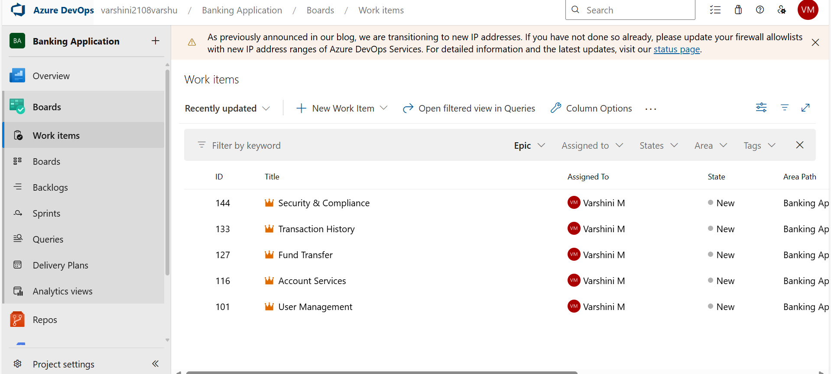

Features:
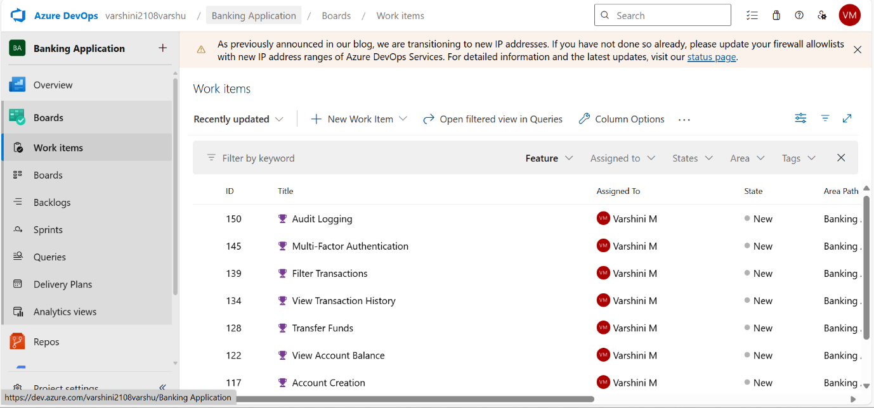

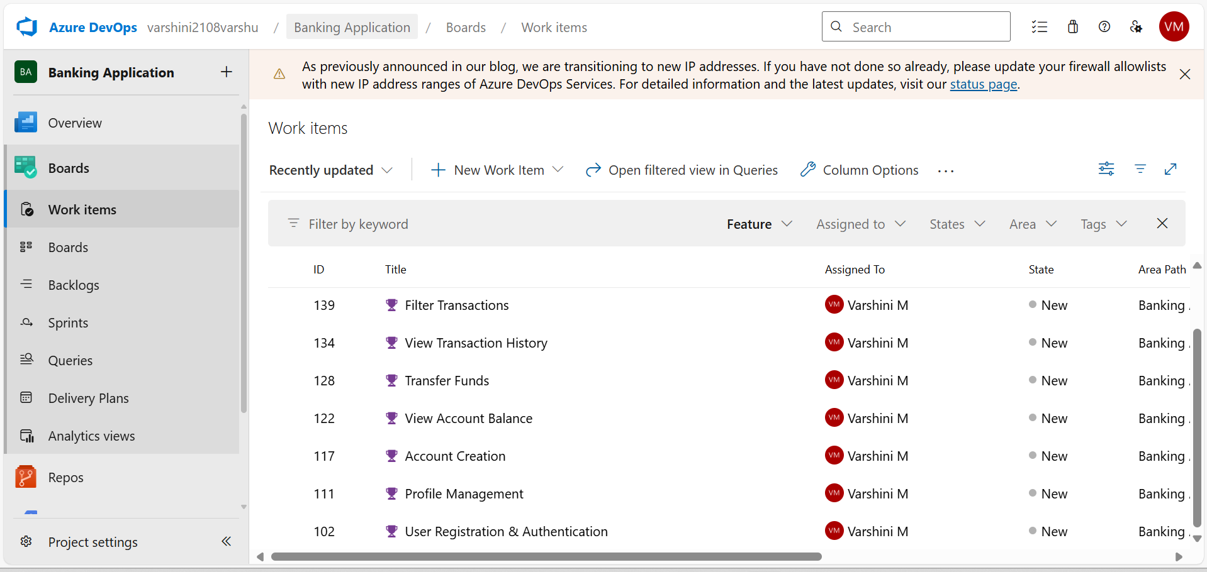

User Story:
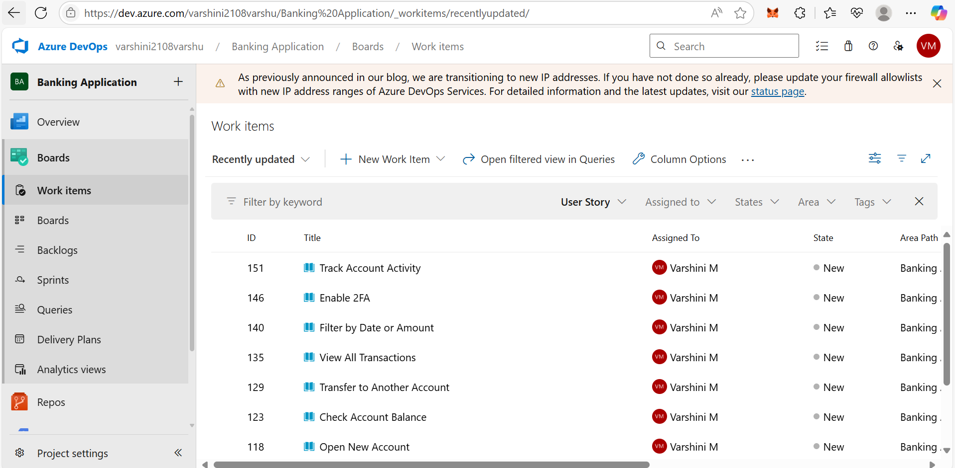
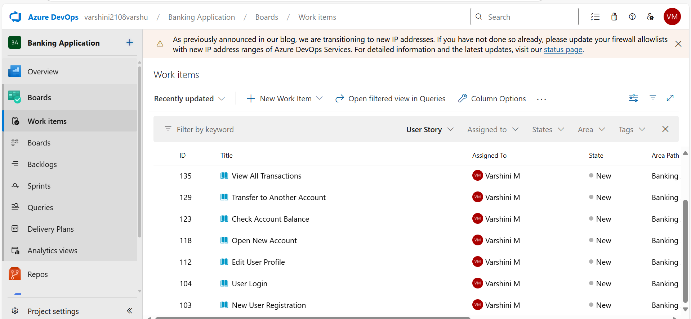

Tasks:
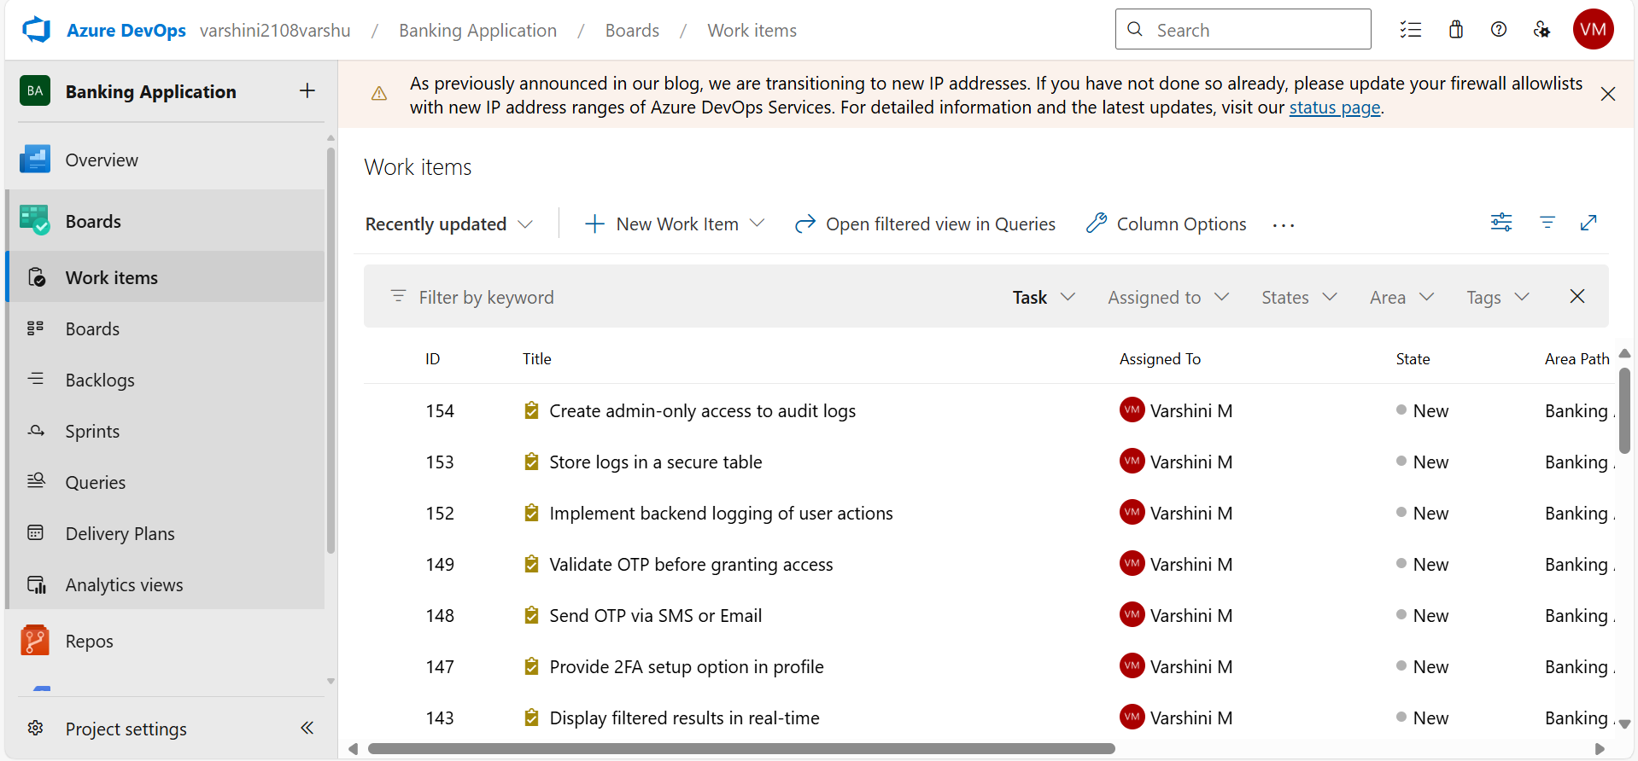
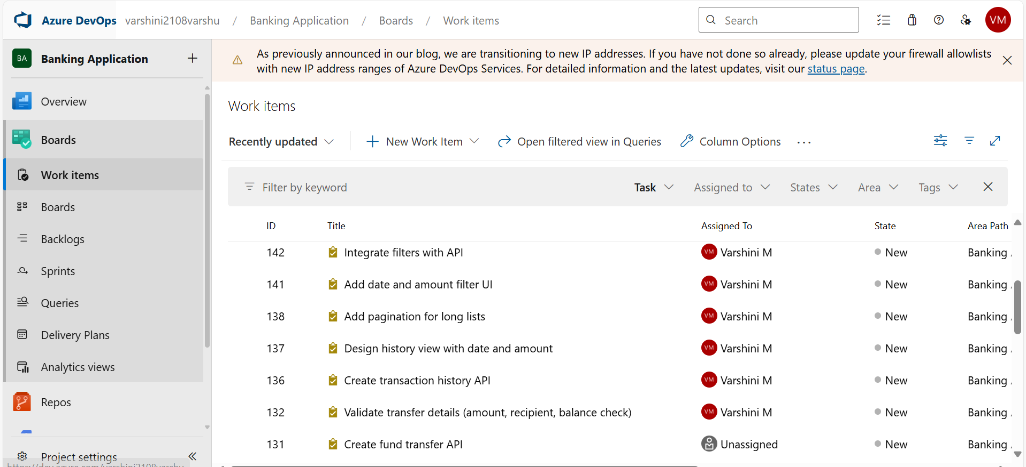
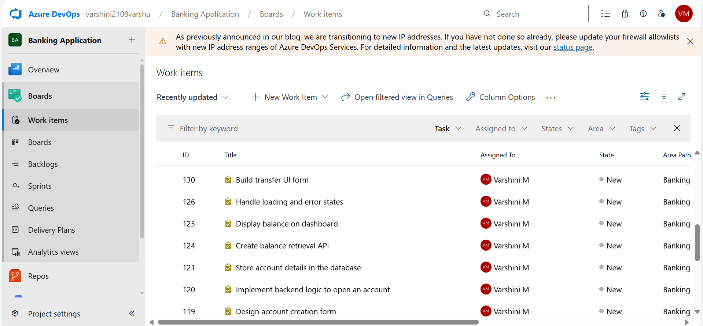
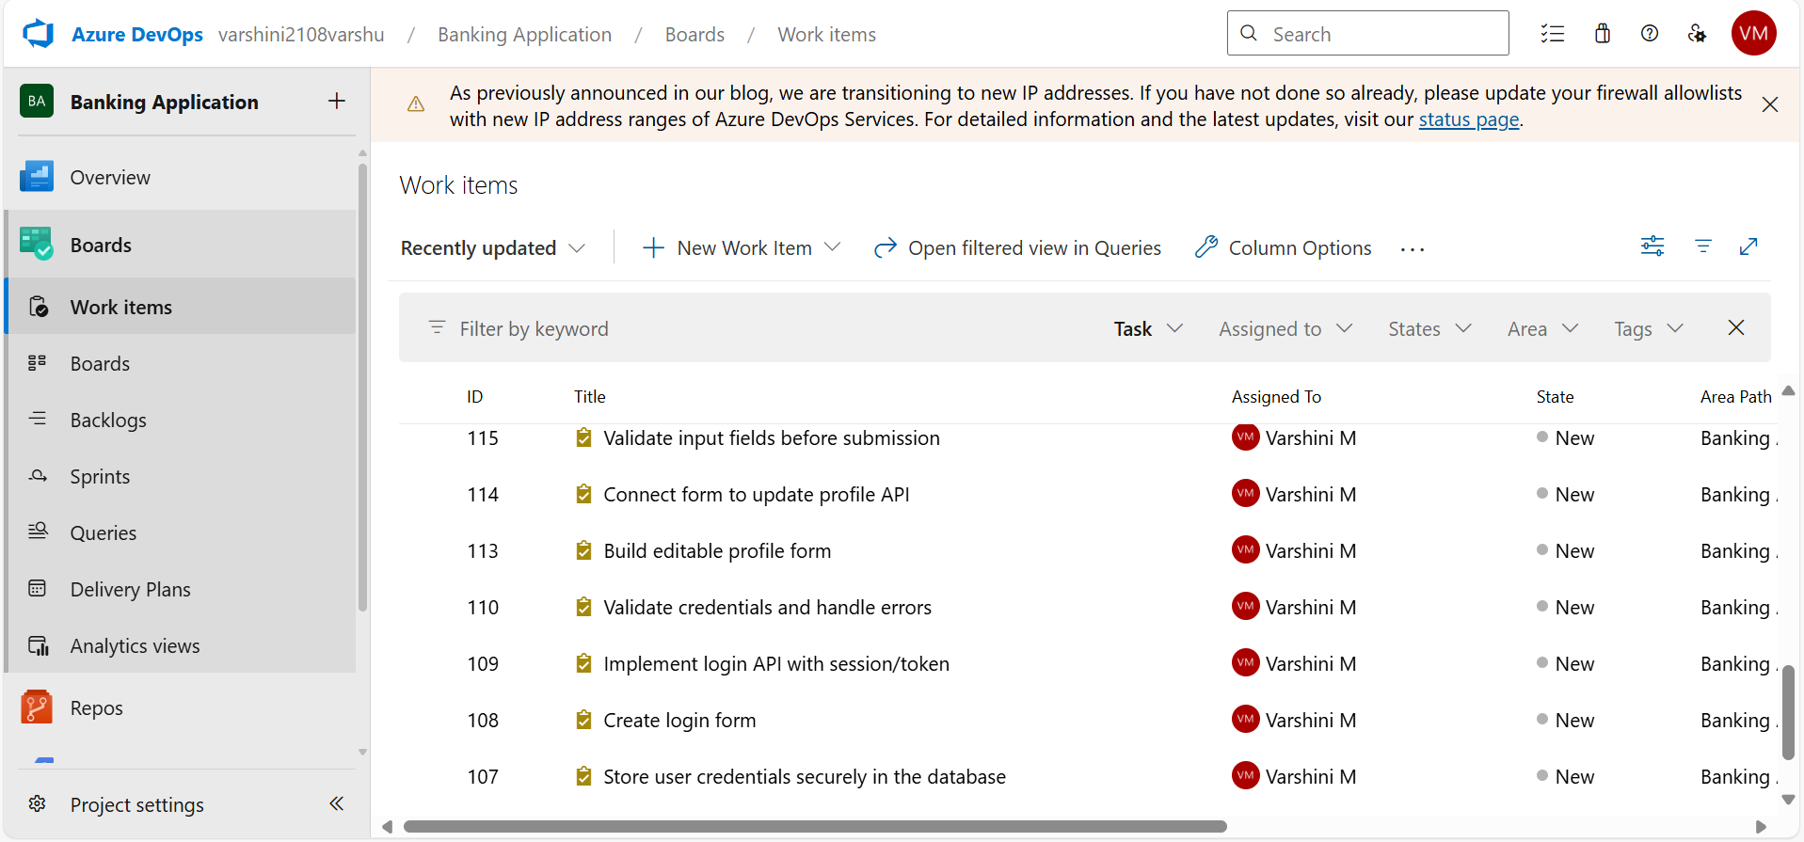
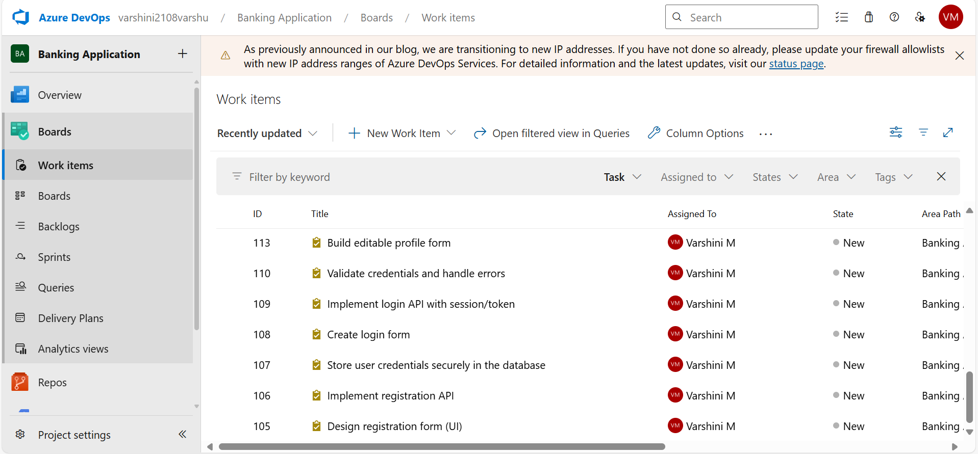

Boards:
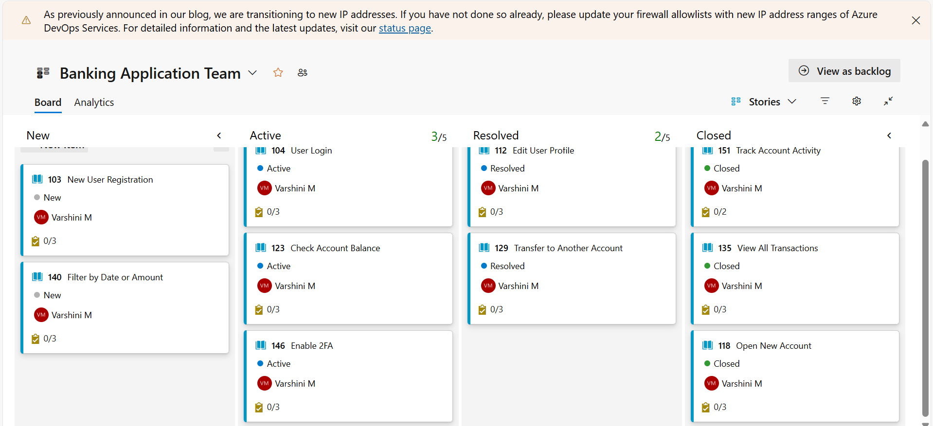

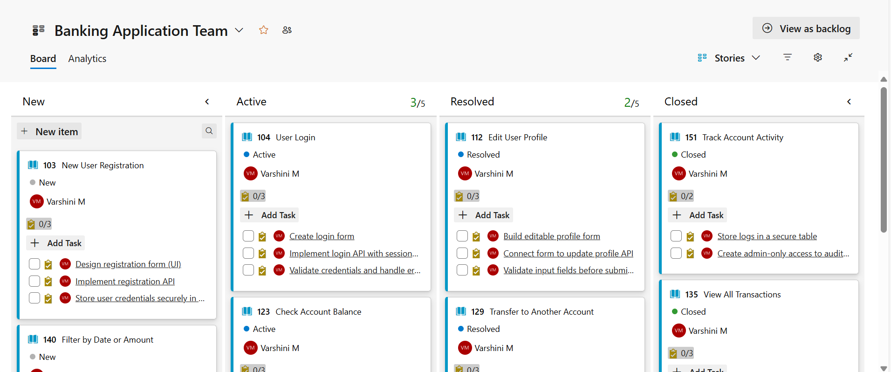

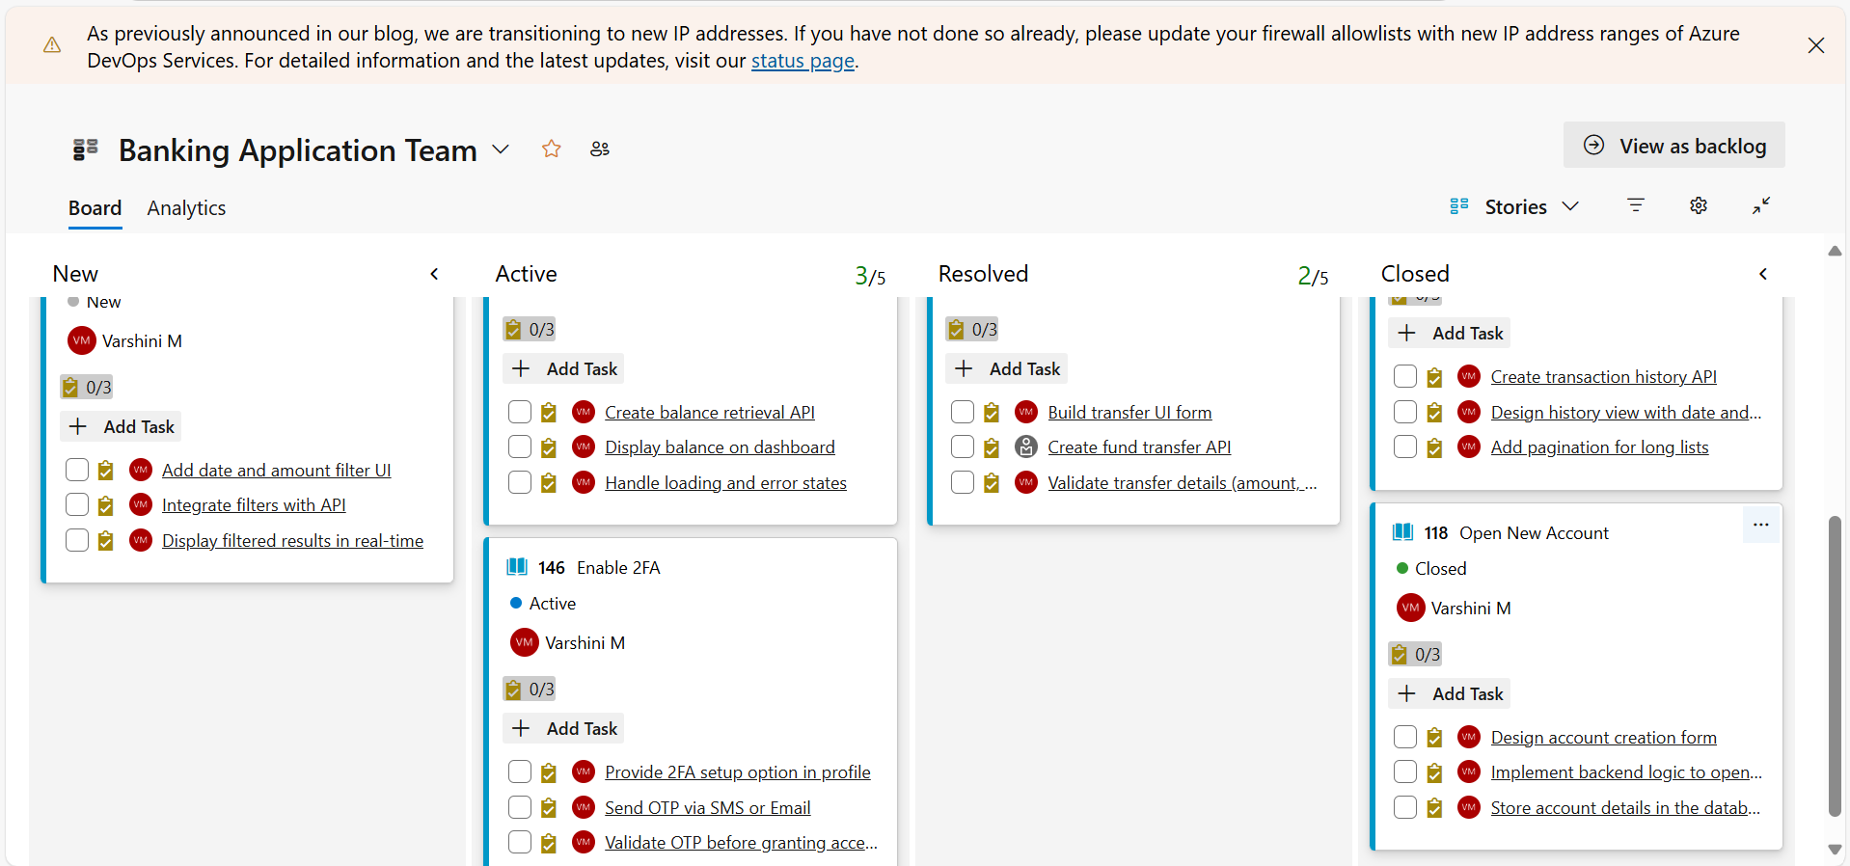

PART 2 - Azure DevOps Git Setup

project structure:
Banking Application/
├── README.md
├── src/
│ └── app.py
└── .azure-pipelines.yml

Create a Python file(e.g. app.py)
#app.py
print("Banking Application Placeholder")
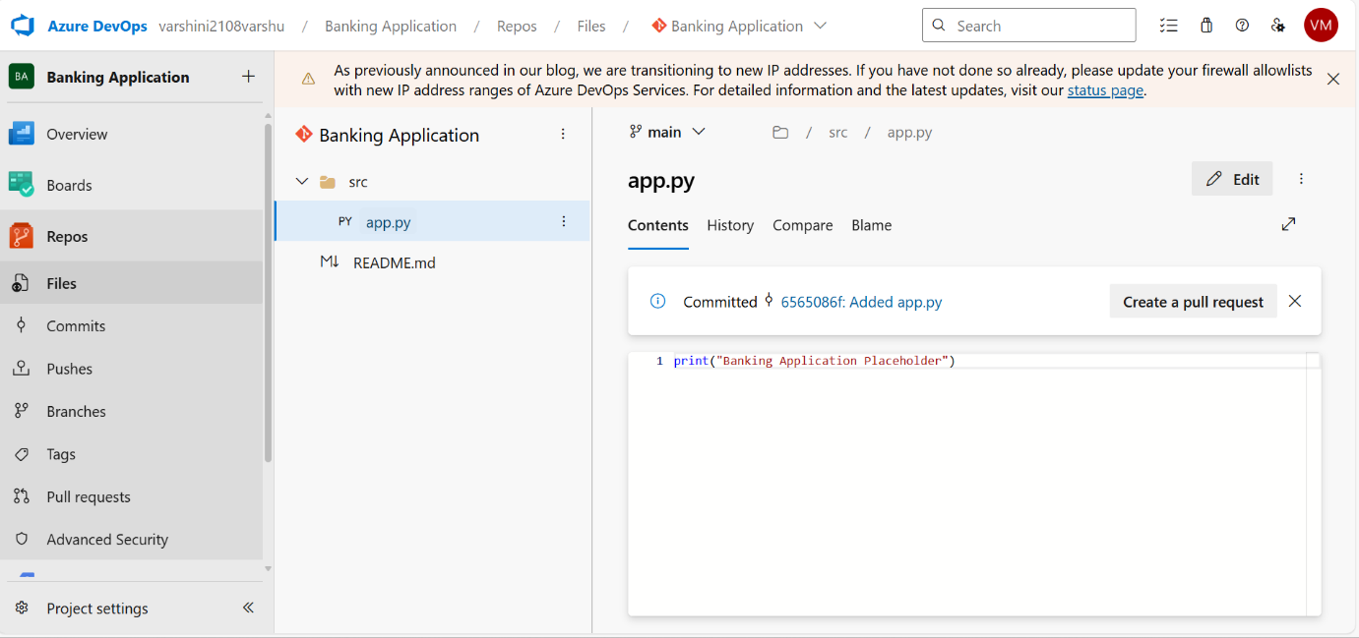

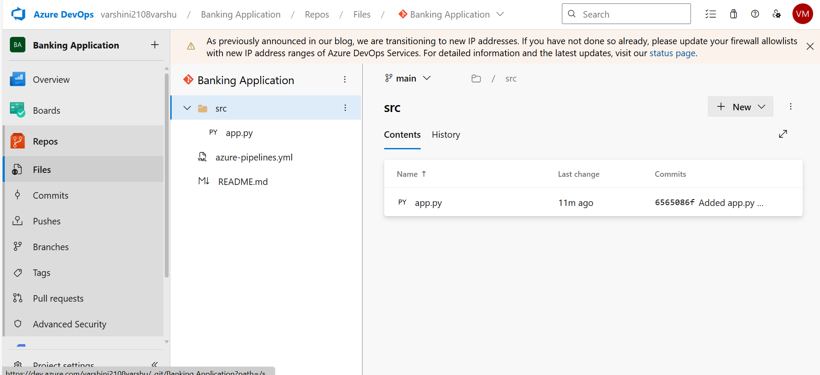

PART 3 - Configure CI/CD Pipeline
1. Create Simple Pipeline
Example: azure-pipelines.yml
trigger:
- main

pool:
vmImage: 'ubuntu-latest'

steps:
- task: UsePythonVersion@0
inputs:
versionSpec: '3.x'

- script: python src/app.py
displayName: 'Run Banking Application Placeholder'
